

Analyzing COVID-19 Data to predict Death Rate, in the Future if We have to face similar crisis like COVID-19.
Group Details
PS/2021/068 MDDI Senadheera
PS/2021/050 JANN Jayasinghe
PS/2021/169 GLL Hansamali
PS/2021/025 AJMVS Jayasinghe
PS/2021/176 MDRD Rupasighe
PS/2021/009 DSY Dissanayaka
PS/2021/111 LMIK Thilakasiri
PS/2021/069 SASC Ariyarathna
PS/2021/112 GJE Amarasinghe
PS/2021/121 SD Hendavitharana

STAT 31631 – Statistical Modeling
Department of Statistics & Computer
Science University of Kelaniya
Academic Year 2023/2024
By
Group - 09
Abstract
The covid-19 virus, which emerged in December 2019. It caused significant crisis in the whole world make significant impact on mortality rate, also recent surges still being reported in country like India. To prepare for Future pandemics like COVID-19, this study aims to develop predictive multiple linear regression model for estimating total deaths, including regional (like Continent, WHO.Region) disparities in mortality rates, The primary objective is to construct a multiple linear regression model to predict pandemic-induced fatalities. The secondary objectives are identifying key mortality predictors, developing region-specific models (by Continent, WHO.Region) and examining healthcare disparities. Exploratory objectives focus on deriving policy recommendations to mitigate future risks. The novelty of this study lies in its region\continent-specific modeling approach, which accounts for variations in healthcare infrastructure (like Asia vs Europe) and cultural factors influencing covid disease spread. By comparing regression coefficients across regions, the study highlights the most significant factors affecting mortality in different contexts. The findings will provide actionable insights for policymakers to develop and strengthen healthcare systems and reduce deaths and to reduce infections in future Outbreaks.
Introduction
We know that in December 2019, the world faced a major crisis due to the COVID-19 Virus. Many people lost their lives during that time. Recently, new COVID-19 cases have also been reported in India. Our main objective is to fit a linear regression model to predict the total Deaths in case we face a similar pandemic in the future. The novelty of this study lies in its region or continent specific
Objectives
- Primary Objective:
  - Develop a linear regression model to predict the Total deaths in case we face a similar pandemic in the future.
- Secondary Objectives:
  - To identify the most significant predictors of pandemic mortality rates.
  - Develop continent/region-specific regression model.
  - To analyze regional disparities (by continent or WHO Region) in death rates.
- Exploratory Objectives:
  - To provide actionable insights for policymakers to mitigate mortality risks in Future pandemics.

Novelty
Develop continent/region-specific regression model that accounts for:
- Different baseline healthcare systems (Asia vs Europe).
- Cultural factors affecting spread.
Compare coefficient differences across regions to identify the most impactful factors in different contexts.
Advantages
Identify the continent/regional health care differences and provide insights to improve healthcare system.
Provide actionable insights for policymakers to mitigate mortality risks in future pandemics.

Dataset link
https://www.kaggle.com/datasets/imdevskp/corona-virus-report
Gannt Chart
Progress | May |  |  |  | June |  |  |  | July
Progress | 2 | 3 | 4 | 5 | 1 | 2 | 3 | 4 | 1 | 2
Finding data set suitable for fit a linear regression model & confirm data set under the guidance of lectures and demonstrators
Choose a suitable topic and Objectives for the data set and select novelty for the data set discussing with group members
Submission of the 1st report.

Methodology
  - Research Design
This study employs quantitative research design using secondary data analysis of COVID-19 pandemic statistics to develop predictive models for mortality rates to if, we have to face similar pandemics like COVID-19 in the future.
  - Data Collection
The dataset was sourced from Kaggle: Worldometer COVID-19 data, that containing comprehensive statistics across 213 countries/regions.
Key variables include:
- Demographic data (population)
- Infection metrics (total cases, new cases)
- Outcome metrics (total deaths, new deaths)
- Recovery metrics (total recovered)
- Healthcare capacity indicators (total test conducted)
- Geographic classifications (continent, WHO region)

  - Data Preparation
- Data cleaning:
- Handling missing values
  - We decided to remove some variables (NewCases, NewRecovered, NewDeaths, ActiveCases) which cases lot of missing values and there are variables for these variables with totals (TotalCases, TotalDeaths & TotalRecovered). So, removing NewCases, NewRecovered, NewDeaths & ActiveCases make no impact.
  - But we have removed the variable Series.Critical only because of the missing values.
  - After we remove data with missing values.
- We didn’t remove outliers because of real world healthcare data.

- Data Splitting:
  - 80% training set for model development
  - 20% test set for model validation

  - Analytical Approach for the Objectives
- Global Model Development (Primary Objective):
- Multiple linear regression to predict total deaths.
- Identify potential predictors: total cases, population, test/million, healthcare indicators.
- Identify model diagnostics: multicollinearity, heteroscedasticity, normality of residuals.
- Secondary Objective:
- Separate regression models for region/continent/WHO region-Specific Models
- Interaction terms between key predictors and region indicators.
- Model Evaluation:
- R-squared & adjusted R-squared for Goodness-of-fit
- Comparison of global & regional/continent model performance
- Cross-validation to assess generalizability
- Secondary Analysis:
- ANOVA to examine regional/continent disparities in death rates
- Correlation analysis to identify significant predictors
- Visualization of reginal patterns in mortality
  - Ethical Consideration
- Proper attribution to original data sources
- Avoidance of causal claims were inappropriate
- Transparent reporting of limitations

Descriptive analysis

  - Overview of Dataset
The data set contains records for 209 countries/regions with 15 variables each. Preliminary examination reveals:

worldometer_data <- read.csv("worldometer_data.csv")
head(worldometer_data)
## Country.Region Continent Population TotalCases NewCases TotalDeaths
## 1 USA North America 331198130 5032179 NA 162804
## 2 Brazil South America 212710692 2917562 NA 98644
## 3 India Asia 1381344997 2025409 NA 41638
## 4 Russia Europe 145940924 871894 NA 14606
## 5 South Africa Africa 59381566 538184 NA 9604
## 6 Mexico North America 129066160 462690 6590 50517
## NewDeaths TotalRecovered NewRecovered ActiveCases Serious.Critical
## 1 NA 2576668 NA 2292707 18296
## 2 NA 2047660 NA 771258 8318
## 3 NA 1377384 NA 606387 8944
## 4 NA 676357 NA 180931 2300
## 5 NA 387316 NA 141264 539
## 6 819 308848 4140 103325 3987
## Tot.Cases.1M.pop Deaths.1M.pop TotalTests Tests.1M.pop WHO.Region
## 1 15194 492 63139605 190640 Americas
## 2 13716 464 13206188 62085 Americas
## 3 1466 30 22149351 16035 South-EastAsia
## 4 5974 100 29716907 203623 Europe
## 5 9063 162 3149807 53044 Africa
## 6 3585 391 1056915 8189 Americas

Geographic Distribution
barplot(table(worldometer_data$Continent), main = "Number countries by Continent")
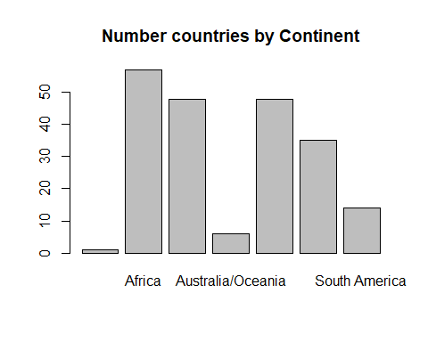
table(worldometer_data$Continent)
##
##

Africa Asia Australia/Oceania
## 1 57 48 6
## Europe North America South America
## 48 35 14

barplot(table(worldometer_data$WHO.Region),main = "Number of countries by WHO.Region")
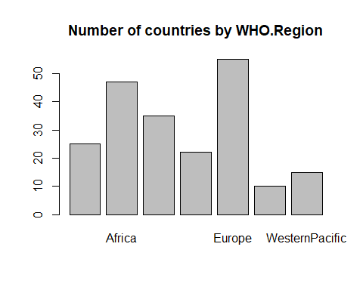
table(worldometer_data$WHO.Region)
##
## Africa Americas
## 25 47 35
## EasternMediterranean Europe South-EastAsia
## 22 55 10
## WesternPacific
## 15

Population Coverage

Population by continent
pop_by_continent <- tapply(worldometer_data$Population, worldometer_data$Continent, sum)
barplot(pop_by_continent,main = "Population by continent")
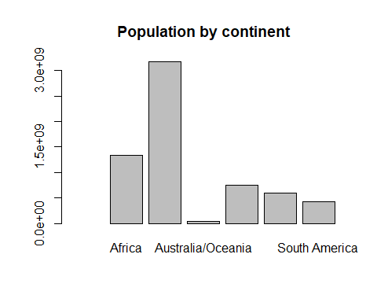
pop_by_continent
## Africa Asia Australia/Oceania
## NA 1343515489 3173656415 40957909
## Europe North America South America
## 747677546 589503467 431110464

Population by WHO region
barplot(tapply(worldometer_data$Population,worldometer_data$WHO.Region,sum),main = "Population by WHO region")
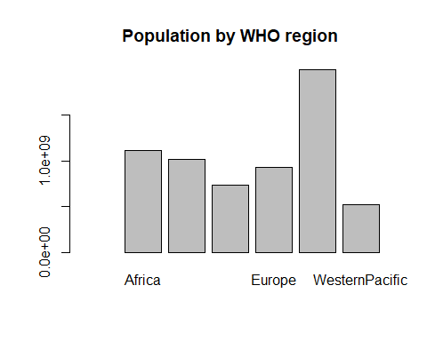
tapply(worldometer_data$Population,worldometer_data$WHO.Region,sum)
## Africa Americas
## NA 1118461393 1018879504
## EasternMediterranean Europe South-EastAsia
## 732007690 927733876 1997512597
## WesternPacific
## 522144861
population <- na.omit(worldometer_data$Population)
range(population)
## [1] 801 1381344997

population range is 802(Vatican City) to 1.38 billion (India)

Key Variable Distribution

Total Cases:
total_caess <- na.omit(worldometer_data$TotalCases)
range(total_caess)
## [1] 10 5032179

Global range : 10(western Sahara) to 5032179 (USA)

mean(total_caess)
## [1] 91718.5
hist(total_caess)
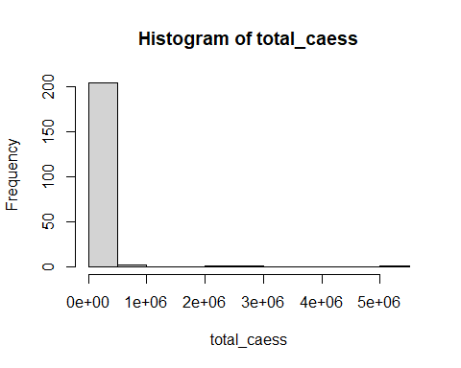
we can see highly skewed distribution, most countries below 100000 cases

Total deaths
total_deaths <- na.omit(worldometer_data$TotalDeaths)
range(total_deaths)
## [1] 1 162804

Global death rage in between 0 to 162804

mean(worldometer_data$TotalDeaths,na.rm = TRUE)
## [1] 3792.59

mean death in country is 3792

hist(total_deaths)
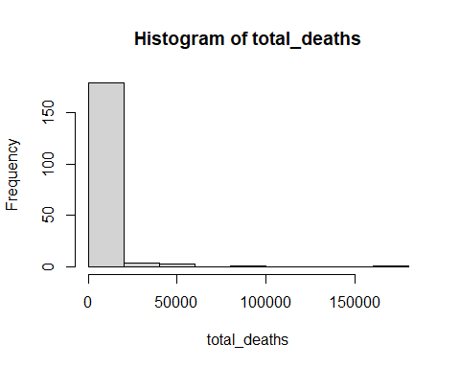 #
count = (total_deaths[total_deaths<=1000])
(nrow(as.matrix(count))/209)*100
## [1] 68.42105

Nearly 68.4% of countries reported <1000 deaths

Case Fatality Rate
corona <- worldometer_data[,-c(5,7,9,10,11)]
df <- na.omit(corona)
CFR <-(df$TotalDeaths / df$TotalCases) * 100
mean(CFR)
## [1] 3.036697

Global Case Fatality Rate is 3.03%
range(CFR)
## [1] 0.04949134 28.73303167

range of Case Fatality Rate is 0 to 28.7 %

Regional Disparities

Cases per Million Population
cases <- worldometer_data$Tot.Cases.1M.pop
range(cases,na.rm = TRUE)
## [1] 3 39922

Cases per Million Population Highest is Quater (39922) and lowest is Laos (3)

Continent Averages
tapply(worldometer_data$Tot.Cases.1M.pop,worldometer_data$Continent,mean)
## Africa Asia Australia/Oceania
## NA 1130.807 4008.938 241.000
## Europe North America South America
## 4363.625 2529.914 7745.786
barplot(tapply(worldometer_data$Tot.Cases.1M.pop,worldometer_data$Continent,mean))
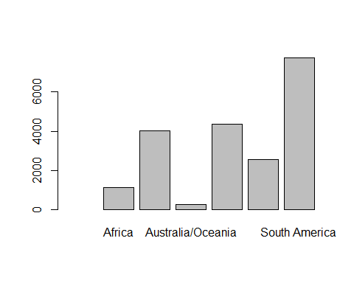

Deaths per Million Population
deaths <- worldometer_data$Deaths.1M.pop
range(deaths,na.rm = TRUE)
## [1] 0.08 1238.00

Deaths per Million Population Highest is San Marino(1238) and lowest is Burundi(0.08)

Continental averages
tapply(worldometer_data$Deaths.1M.pop,worldometer_data$Continent,mean,na.rm = TRUE)
## Africa Asia Australia/Oceania
## NaN 18.24145 43.97143 3.82500
## Europe North America South America
## 214.95556 110.60714 216.76923
barplot(tapply(worldometer_data$Deaths.1M.pop,worldometer_data$Continent,mean,na.rm = TRUE))
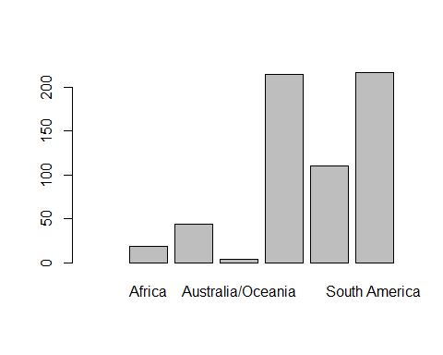

Healthcare Capacity Indicators

Total testing
test <- worldometer_data$TotalTests
range(test,na.rm = TRUE)
## [1] 61 63139605

USA has the highest Healthcare Capacity over 63139605 tests

Montserrat has the lowest Healthcare Capacity which is only 61 test

Continent averages
tapply(worldometer_data$TotalTests,worldometer_data$Continent,mean,na.rm = TRUE)
## Africa Asia Australia/Oceania
## NaN 197133.0 1420735.2 858801.8
## Europe North America South America
## 2045225.8 2063928.9 1598544.1
barplot(tapply(worldometer_data$TotalTests,worldometer_data$Continent,mean,na.rm = TRUE))
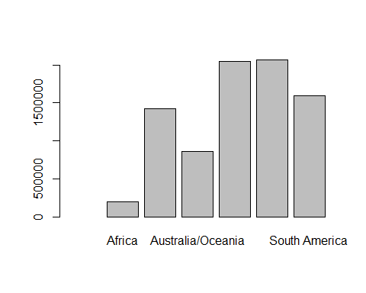

Correlations
correlation <- cor(na.omit(corona[,-c(1,2,11)]))
correlation
## Population TotalCases TotalDeaths TotalRecovered
## Population 1.00000000 0.54338501 0.43795429 0.58785407
## TotalCases 0.54338501 1.00000000 0.95496099 0.98568247
## TotalDeaths 0.43795429 0.95496099 1.00000000 0.93513544
## TotalRecovered 0.58785407 0.98568247 0.93513544 1.00000000
## Tot.Cases.1M.pop -0.02410002 0.24560317 0.22719400 0.26220930
## Deaths.1M.pop 0.02043201 0.28430834 0.38474649 0.29052272
## TotalTests 0.50173948 0.90460050 0.84343006 0.86933559
## Tests.1M.pop -0.07844237 0.03969952 0.02976143 0.03722018
## Tot.Cases.1M.pop Deaths.1M.pop TotalTests Tests.1M.pop
## Population -0.02410002 0.02043201 0.5017395 -0.07844237
## TotalCases 0.24560317 0.28430834 0.9046005 0.03969952
## TotalDeaths 0.22719400 0.38474649 0.8434301 0.02976143
## TotalRecovered 0.26220930 0.29052272 0.8693356 0.03722018
## Tot.Cases.1M.pop 1.00000000 0.50610859 0.1848900 0.31844108
## Deaths.1M.pop 0.50610859 1.00000000 0.2224010 0.13493032
## TotalTests 0.18489000 0.22240101 1.0000000 0.10382784
## Tests.1M.pop 0.31844108 0.13493032 0.1038278 1.00000000
pairs(na.omit(corona[,-c(1,2,11)]))
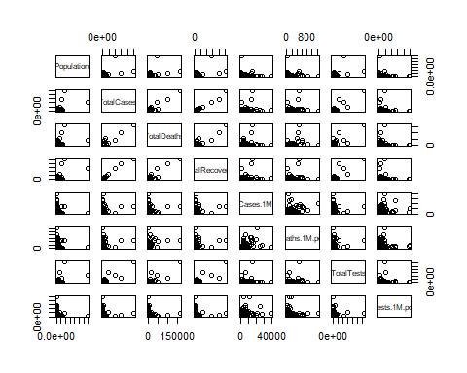

Correlation of population
correlation[,1]
## Population TotalCases TotalDeaths TotalRecovered
## 1.00000000 0.54338501 0.43795429 0.58785407
## Tot.Cases.1M.pop Deaths.1M.pop TotalTests Tests.1M.pop
## -0.02410002 0.02043201 0.50173948 -0.07844237

Correlation of TotalCases
correlation[,2]
## Population TotalCases TotalDeaths TotalRecovered
## 0.54338501 1.00000000 0.95496099 0.98568247
## Tot.Cases.1M.pop Deaths.1M.pop TotalTests Tests.1M.pop
## 0.24560317 0.28430834 0.90460050 0.03969952

Correlation of TotalDeaths
correlation[,3]
## Population TotalCases TotalDeaths TotalRecovered
## 0.43795429 0.95496099 1.00000000 0.93513544
## Tot.Cases.1M.pop Deaths.1M.pop TotalTests Tests.1M.pop
## 0.22719400 0.38474649 0.84343006 0.02976143

Correlation of TotalRecovered
correlation[,4]
## Population TotalCases TotalDeaths TotalRecovered
## 0.58785407 0.98568247 0.93513544 1.00000000
## Tot.Cases.1M.pop Deaths.1M.pop TotalTests Tests.1M.pop
## 0.26220930 0.29052272 0.86933559 0.03722018

Correlation of Tot.Cases.1M.pop
correlation[,5]
## Population TotalCases TotalDeaths TotalRecovered
## -0.02410002 0.24560317 0.22719400 0.26220930
## Tot.Cases.1M.pop Deaths.1M.pop TotalTests Tests.1M.pop
## 1.00000000 0.50610859 0.18489000 0.31844108

Correlation of Deaths.1M.pop
correlation[,6]
## Population TotalCases TotalDeaths TotalRecovered
## 0.02043201 0.28430834 0.38474649 0.29052272
## Tot.Cases.1M.pop Deaths.1M.pop TotalTests Tests.1M.pop
## 0.50610859 1.00000000 0.22240101 0.13493032

Correlation of TotalTests
correlation[,7]
## Population TotalCases TotalDeaths TotalRecovered
## 0.5017395 0.9046005 0.8434301 0.8693356
## Tot.Cases.1M.pop Deaths.1M.pop TotalTests Tests.1M.pop
## 0.1848900 0.2224010 1.0000000 0.1038278

Correlation of Tests.1M.pop
correlation[,8]
## Population TotalCases TotalDeaths TotalRecovered
## -0.07844237 0.03969952 0.02976143 0.03722018
## Tot.Cases.1M.pop Deaths.1M.pop TotalTests Tests.1M.pop
## 0.31844108 0.13493032 0.10382784 1.00000000

Results and discussion
#install.packages("caTools")
#install.packages("car")
#install.packages("quantmod")
#install.packages("MASS")
#install.packages("corrplot")
#install.packages("leaps")
#install.packages("Metrics")
#install.packages("tidyr")
#install.packages("dplyr")
#install.packages("randtests")
#install.packages("lmtest")
#install.packages("nlme")
library(caTools)
## Warning: package 'caTools' was built under R version 4.4.3
library(car)
## Warning: package 'car' was built under R version 4.4.3
## Loading required package: carData
## Warning: package 'carData' was built under R version 4.4.3
library(quantmod)
## Warning: package 'quantmod' was built under R version 4.4.3
## Loading required package: xts
## Warning: package 'xts' was built under R version 4.4.3
## Loading required package: zoo
## Warning: package 'zoo' was built under R version 4.4.3
##
## Attaching package: 'zoo'
## The following objects are masked from 'package:base':
##
## as.Date, as.Date.numeric
## Loading required package: TTR
## Warning: package 'TTR' was built under R version 4.4.3
## Registered S3 method overwritten by 'quantmod':
## method from
## as.zoo.data.frame zoo
library(MASS)
## Warning: package 'MASS' was built under R version 4.4.3
library(corrplot)
## Warning: package 'corrplot' was built under R version 4.4.3
## corrplot 0.95 loaded
library(Metrics)
## Warning: package 'Metrics' was built under R version 4.4.3
library(tidyr)
## Warning: package 'tidyr' was built under R version 4.4.3
library(dplyr)
## Warning: package 'dplyr' was built under R version 4.4.3
##
## ######################### Warning from 'xts' package ##########################
## # #
## # The dplyr lag() function breaks how base R's lag() function is supposed to #
## # work, which breaks lag(my_xts). Calls to lag(my_xts) that you type or #
## # source() into this session won't work correctly. #
## # #
## # Use stats::lag() to make sure you're not using dplyr::lag(), or you can add #
## # conflictRules('dplyr', exclude = 'lag') to your .Rprofile to stop #
## # dplyr from breaking base R's lag() function. #
## # #
## # Code in packages is not affected. It's protected by R's namespace mechanism #
## # Set `options(xts.warn_dplyr_breaks_lag = FALSE)` to suppress this warning. #
## # #
## ###############################################################################
##
## Attaching package: 'dplyr'
## The following object is masked from 'package:MASS':
##
## select
## The following objects are masked from 'package:xts':
##
## first, last
## The following object is masked from 'package:car':
##
## recode
## The following objects are masked from 'package:stats':
##
## filter, lag
## The following objects are masked from 'package:base':
##
## intersect, setdiff, setequal, union
library(leaps)
## Warning: package 'leaps' was built under R version 4.4.3
library(randtests)
library(lmtest)
## Warning: package 'lmtest' was built under R version 4.4.3
library(nlme)
## Warning: package 'nlme' was built under R version 4.4.3
##
## Attaching package: 'nlme'
## The following object is masked from 'package:dplyr':
##
## collapse
worldometer_data <- read.csv("worldometer_data.csv")
head(worldometer_data)
## Country.Region Continent Population TotalCases NewCases TotalDeaths
## 1 USA North America 331198130 5032179 NA 162804
## 2 Brazil South America 212710692 2917562 NA 98644
## 3 India Asia 1381344997 2025409 NA 41638
## 4 Russia Europe 145940924 871894 NA 14606
## 5 South Africa Africa 59381566 538184 NA 9604
## 6 Mexico North America 129066160 462690 6590 50517
## NewDeaths TotalRecovered NewRecovered ActiveCases Serious.Critical
## 1 NA 2576668 NA 2292707 18296
## 2 NA 2047660 NA 771258 8318
## 3 NA 1377384 NA 606387 8944
## 4 NA 676357 NA 180931 2300
## 5 NA 387316 NA 141264 539
## 6 819 308848 4140 103325 3987
## Tot.Cases.1M.pop Deaths.1M.pop TotalTests Tests.1M.pop WHO.Region
## 1 15194 492 63139605 190640 Americas
## 2 13716 464 13206188 62085 Americas
## 3 1466 30 22149351 16035 South-EastAsia
## 4 5974 100 29716907 203623 Europe
## 5 9063 162 3149807 53044 Africa
## 6 3585 391 1056915 8189 Americas
names(worldometer_data)
## [1] "Country.Region" "Continent" "Population" "TotalCases"
## [5] "NewCases" "TotalDeaths" "NewDeaths" "TotalRecovered"
## [9] "NewRecovered" "ActiveCases" "Serious.Critical" "Tot.Cases.1M.pop"
## [13] "Deaths.1M.pop" "TotalTests" "Tests.1M.pop" "WHO.Region"
str(worldometer_data)
## 'data.frame': 209 obs. of 16 variables:
## $ Country.Region : chr "USA" "Brazil" "India" "Russia" ...
## $ Continent : chr "North America" "South America" "Asia" "Europe" ...
## $ Population : int 331198130 212710692 1381344997 145940924 59381566 129066160 33016319 19132514 50936262 46756648 ...
## $ TotalCases : int 5032179 2917562 2025409 871894 538184 462690 455409 366671 357710 354530 ...
## $ NewCases : int NA NA NA NA NA 6590 NA NA NA NA ...
## $ TotalDeaths : int 162804 98644 41638 14606 9604 50517 20424 9889 11939 28500 ...
## $ NewDeaths : int NA NA NA NA NA 819 NA NA NA NA ...
## $ TotalRecovered : int 2576668 2047660 1377384 676357 387316 308848 310337 340168 192355 NA ...
## $ NewRecovered : int NA NA NA NA NA 4140 NA NA NA NA ...
## $ ActiveCases : int 2292707 771258 606387 180931 141264 103325 124648 16614 153416 NA ...
## $ Serious.Critical: int 18296 8318 8944 2300 539 3987 1426 1358 1493 617 ...
## $ Tot.Cases.1M.pop: int 15194 13716 1466 5974 9063 3585 13793 19165 7023 7582 ...
## $ Deaths.1M.pop : num 492 464 30 100 162 391 619 517 234 610 ...
## $ TotalTests : int 63139605 13206188 22149351 29716907 3149807 1056915 2493429 1760615 1801835 7064329 ...
## $ Tests.1M.pop : int 190640 62085 16035 203623 53044 8189 75521 92022 35374 151087 ...
## $ WHO.Region : chr "Americas" "Americas" "South-EastAsia" "Europe" ...

We dicided to remove NewCases, NewDeaths, NewRecovered because they have lot of missing values and there are variables with totals (TotalCases, TotalDeaths ,TotalRecovered).

corona <- worldometer_data[,-c(1,5,7,9)]
head(corona)
## Continent Population TotalCases TotalDeaths TotalRecovered ActiveCases
## 1 North America 331198130 5032179 162804 2576668 2292707
## 2 South America 212710692 2917562 98644 2047660 771258
## 3 Asia 1381344997 2025409 41638 1377384 606387
## 4 Europe 145940924 871894 14606 676357 180931
## 5 Africa 59381566 538184 9604 387316 141264
## 6 North America 129066160 462690 50517 308848 103325
## Serious.Critical Tot.Cases.1M.pop Deaths.1M.pop TotalTests Tests.1M.pop
## 1 18296 15194 492 63139605 190640
## 2 8318 13716 464 13206188 62085
## 3 8944 1466 30 22149351 16035
## 4 2300 5974 100 29716907 203623
## 5 539 9063 162 3149807 53044
## 6 3987 3585 391 1056915 8189
## WHO.Region
## 1 Americas
## 2 Americas
## 3 South-EastAsia
## 4 Europe
## 5 Africa
## 6 Americas

Total number of missing values
sum(is.na(corona))
## [1] 176
n = nrow(corona)

missing values percentage of Serious.critical cases
(sum(is.na(corona$Serious.Critical)) / n) * 100
## [1] 41.62679

missing values percentage of ActiveCases cases
(sum(is.na(corona$ActiveCases)) / n) * 100
## [1] 1.913876

missing values percentage of Population cases
(sum(is.na(corona$Population)) / n) * 100
## [1] 0.4784689

missing values percentage of TotalCases
(sum(is.na(corona$TotalCases)) / n) * 100
## [1] 0

missing values percentage of TotalDeaths
(sum(is.na(corona$TotalDeaths)) / n) * 100
## [1] 10.04785

missing values percentage of TotalRecovered
(sum(is.na(corona$TotalRecovered)) / n) * 100
## [1] 1.913876

missing values percentage of Tot.Cases.1M.pop
(sum(is.na(corona$Tot.Cases.1M.pop)) / n) * 100
## [1] 0.4784689

missing values percentage of Deaths.1M.pop
(sum(is.na(corona$Deaths.1M.pop)) / n) * 100
## [1] 10.52632

missing values percentage of TotalTests
(sum(is.na(corona$TotalTests)) / n) * 100
## [1] 8.61244

missing values percentage of Tests.1M.pop
(sum(is.na(corona$Tests.1M.pop)) / n) * 100
## [1] 8.61244

missing values percentage of WHO.Region
(sum(is.na(corona$WHO.Region)) / n) * 100
## [1] 0

missing values percentage of Continent
(sum(is.na(corona$Continent)) / n) * 100
## [1] 0
set.seed(68)

We can see that, Serious.Critical has a high missing value percentage (over 41. %), So we cannot simply remove the missing values. So, we must use imputation methods like,

1. Mean Imputation

2. Median Imputation

Let’s first use mean Imputation for Serious.Critical

corona1 <- corona
corona1$Serious.Critical[is.na(corona1$Serious.Critical)] <- mean(corona1$Serious.Critical, na.rm = TRUE)
(sum(is.na(corona1$Serious.Critical)) / n) * 100
## [1] 0
sum(is.na(corona1))
## [1] 89
df1 <- na.omit(corona1)
sum(is.na(df1))
## [1] 0
nrow(df1)
## [1] 169
names(df1)
## [1] "Continent" "Population" "TotalCases" "TotalDeaths"
## [5] "TotalRecovered" "ActiveCases" "Serious.Critical" "Tot.Cases.1M.pop"
## [9] "Deaths.1M.pop" "TotalTests" "Tests.1M.pop" "WHO.Region"

Set split data set (80/20)
split.ratio <- 0.8

Split the dataset into training and test sets
df1_bound <- ceiling(nrow(df1)*split.ratio)
df1_bound
## [1] 136

Training data part
train1 = df1 %>% slice_sample(n = df1_bound, replace = FALSE)
head(train1)
## Continent Population TotalCases TotalDeaths TotalRecovered ActiveCases
## 1 Europe 5794279 14306 617 12787 902
## 2 Africa 59381566 538184 9604 387316 141264
## 3 Asia 40306025 140603 5161 101025 34417
## 4 Europe 3278650 13396 384 7042 5970
## 5 Asia 69817894 3330 58 3148 124
## 6 Europe 174022 597 47 533 17
## Serious.Critical Tot.Cases.1M.pop Deaths.1M.pop TotalTests Tests.1M.pop
## 1 2.0000 2469 106.0 1654512 285542
## 2 539.0000 9063 162.0 3149807 53044
## 3 517.0000 3488 128.0 1092741 27111
## 4 534.3934 4086 117.0 147021 44842
## 5 1.0000 48 0.8 749213 10731
## 6 534.3934 3431 270.0 30721 176535
## WHO.Region
## 1 Europe
## 2 Africa
## 3 EasternMediterranean
## 4 Europe
## 5 South-EastAsia
## 6
nrow(train1)
## [1] 136

Test data part
test1 <- df1[-as.numeric(rownames(train1)),]
head(test1)
## Continent Population TotalCases TotalDeaths TotalRecovered ActiveCases
## 152 Africa 219544 878 15 797 66
## 153 Africa 2356075 804 2 63 739
## 154 North America 393616 761 14 91 656
## 155 Asia 97425470 747 10 392 345
## 156 Africa 2143943 742 23 175 544
## 158 Europe 33938 699 42 657 0
## Serious.Critical Tot.Cases.1M.pop Deaths.1M.pop TotalTests Tests.1M.pop
## 152 534.3934 3999 68.0 3079 14025
## 153 1.0000 341 0.8 68423 29041
## 154 1.0000 1933 36.0 4814 12230
## 155 534.3934 8 0.1 482456 4952
## 156 534.3934 346 11.0 8771 4091
## 158 534.3934 20596 1238.0 6068 178797
## WHO.Region
## 152 Africa
## 153 Africa
## 154 Americas
## 155 WesternPacific
## 156 Africa
## 158 Europe
names(df1)
## [1] "Continent" "Population" "TotalCases" "TotalDeaths"
## [5] "TotalRecovered" "ActiveCases" "Serious.Critical" "Tot.Cases.1M.pop"
## [9] "Deaths.1M.pop" "TotalTests" "Tests.1M.pop" "WHO.Region"
pairs(df1[-c(1,12)])
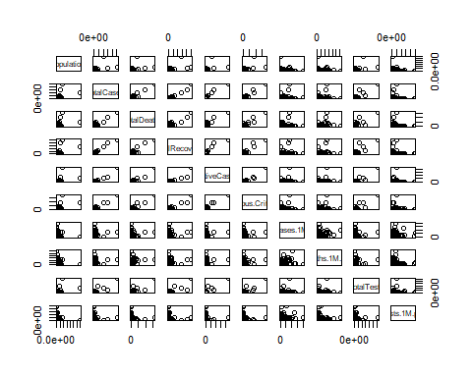

fit the model for mean imputation using Stepwise regression procedure
model1_step <- lm(TotalDeaths ~ ., data = train1)
step_model1 <- stepAIC(model1_step, direction = "both", trace = TRUE)
## Start: AIC=-6457.13
## TotalDeaths ~ Continent + Population + TotalCases + TotalRecovered +
## ActiveCases + Serious.Critical + Tot.Cases.1M.pop + Deaths.1M.pop +
## TotalTests + Tests.1M.pop + WHO.Region
## Warning: attempting model selection on an essentially perfect fit is nonsense
## Df Sum of Sq RSS AIC
## - WHO.Region 6 0 0 -6460.7
## - Tests.1M.pop 1 0 0 -6458.7
## - Serious.Critical 1 0 0 -6458.7
## - TotalTests 1 0 0 -6458.1
## <none> 0 -6457.1
## - Tot.Cases.1M.pop 1 0 0 -6455.4
## - Deaths.1M.pop 1 0 0 -6454.9
## - Continent 5 0 0 -6148.1
## - Population 1 0 0 -6080.5
## - ActiveCases 1 1526605407 1526605407 2247.8
## - TotalRecovered 1 1600606326 1600606326 2254.2
## - TotalCases 1 1681982098 1681982098 2261.0
##
## Step: AIC=-6460.74
## TotalDeaths ~ Continent + Population + TotalCases + TotalRecovered +
## ActiveCases + Serious.Critical + Tot.Cases.1M.pop + Deaths.1M.pop +
## TotalTests + Tests.1M.pop
## Warning: attempting model selection on an essentially perfect fit is nonsense
## Warning: attempting model selection on an essentially perfect fit is nonsense
## Df Sum of Sq RSS AIC
## - Tests.1M.pop 1 0 0 -6462.5
## - Serious.Critical 1 0 0 -6462.3
## - TotalTests 1 0 0 -6462.1
## <none> 0 -6460.7
## - Tot.Cases.1M.pop 1 0 0 -6460.3
## - Deaths.1M.pop 1 0 0 -6459.3
## + WHO.Region 6 0 0 -6457.1
## - Continent 5 0 0 -6149.0
## - Population 1 0 0 -6090.0
## - ActiveCases 1 1546654973 1546654973 2237.6
## - TotalRecovered 1 1625228201 1625228201 2244.3
## - TotalCases 1 1707028664 1707028664 2251.0
##
## Step: AIC=-6462.45
## TotalDeaths ~ Continent + Population + TotalCases + TotalRecovered +
## ActiveCases + Serious.Critical + Tot.Cases.1M.pop + Deaths.1M.pop +
## TotalTests
## Warning: attempting model selection on an essentially perfect fit is nonsense
## Warning: attempting model selection on an essentially perfect fit is nonsense
## Df Sum of Sq RSS AIC
## - Serious.Critical 1 0 0 -6464.1
## - TotalTests 1 0 0 -6464.0
## <none> 0 -6462.5
## - Tot.Cases.1M.pop 1 0 0 -6462.2
## - Deaths.1M.pop 1 0 0 -6461.2
## + Tests.1M.pop 1 0 0 -6460.7
## + WHO.Region 6 0 0 -6458.7
## - Continent 5 0 0 -6150.7
## - Population 1 0 0 -6091.8
## - ActiveCases 1 1556761966 1556761966 2236.4
## - TotalRecovered 1 1632407359 1632407359 2242.9
## - TotalCases 1 1716995134 1716995134 2249.8
##
## Step: AIC=-6464.07
## TotalDeaths ~ Continent + Population + TotalCases + TotalRecovered +
## ActiveCases + Tot.Cases.1M.pop + Deaths.1M.pop + TotalTests
## Warning: attempting model selection on an essentially perfect fit is nonsense
## Warning: attempting model selection on an essentially perfect fit is nonsense
## Df Sum of Sq RSS AIC
## - TotalTests 1 0 0 -6465.7
## <none> 0 -6464.1
## - Tot.Cases.1M.pop 1 0 0 -6463.9
## - Deaths.1M.pop 1 0 0 -6462.8
## + Serious.Critical 1 0 0 -6462.5
## + Tests.1M.pop 1 0 0 -6462.3
## + WHO.Region 6 0 0 -6460.4
## - Continent 5 0 0 -6152.2
## - Population 1 0 0 -6091.9
## - ActiveCases 1 1824219901 1824219901 2256.0
## - TotalRecovered 1 1839046908 1839046908 2257.1
## - TotalCases 1 1998614544 1998614544 2268.4
##
## Step: AIC=-6465.73
## TotalDeaths ~ Continent + Population + TotalCases + TotalRecovered +
## ActiveCases + Tot.Cases.1M.pop + Deaths.1M.pop
## Warning: attempting model selection on an essentially perfect fit is nonsense
## Warning: attempting model selection on an essentially perfect fit is nonsense
## Df Sum of Sq RSS AIC
## <none> 0 -6465.7
## - Tot.Cases.1M.pop 1 0 0 -6465.7
## - Deaths.1M.pop 1 0 0 -6464.5
## + TotalTests 1 0 0 -6464.1
## + Serious.Critical 1 0 0 -6464.0
## + Tests.1M.pop 1 0 0 -6463.8
## + WHO.Region 6 0 0 -6461.7
## - Continent 5 0 0 -6154.0
## - Population 1 0 0 -6087.7
## - ActiveCases 1 1824750340 1824750340 2254.0
## - TotalRecovered 1 1849163447 1849163447 2255.8
## - TotalCases 1 2002111751 2002111751 2266.7
summary(step_model1)
##
## Call:
## lm(formula = TotalDeaths ~ Continent + Population + TotalCases +
## TotalRecovered + ActiveCases + Tot.Cases.1M.pop + Deaths.1M.pop,
## data = train1)
##
## Residuals:
## Min 1Q Median 3Q Max
## -1.308e-10 -2.005e-11 -7.400e-14 7.921e-12 2.855e-10
##
## Coefficients:
## Estimate Std. Error t value Pr(>|t|)
## (Intercept) -7.299e-12 7.805e-12 -9.350e-01 0.351517
## ContinentAsia 6.415e-11 1.173e-11 5.469e+00 2.39e-07 ***
## ContinentAustralia/Oceania 8.585e-11 2.404e-11 3.572e+00 0.000506 ***
## ContinentEurope 6.120e-11 1.201e-11 5.095e+00 1.26e-06 ***
## ContinentNorth America -3.319e-11 1.266e-11 -2.622e+00 0.009841 **
## ContinentSouth America -6.751e-11 1.688e-11 -3.999e+00 0.000109 ***
## Population -1.007e-18 5.199e-20 -1.938e+01 < 2e-16 ***
## TotalCases 1.000e+00 1.017e-15 9.832e+14 < 2e-16 ***
## TotalRecovered -1.000e+00 1.058e-15 -9.449e+14 < 2e-16 ***
## ActiveCases -1.000e+00 1.065e-15 -9.387e+14 < 2e-16 ***
## Tot.Cases.1M.pop 1.336e-15 9.714e-16 1.375e+00 0.171521
## Deaths.1M.pop -5.628e-14 3.251e-14 -1.731e+00 0.085869 .
## ---
## Signif. codes: 0 '***' 0.001 '**' 0.01 '*' 0.05 '.' 0.1 ' ' 1
##
## Residual standard error: 4.551e-11 on 124 degrees of freedom
## Multiple R-squared: 1, Adjusted R-squared: 1
## F-statistic: 6.603e+29 on 11 and 124 DF, p-value: < 2.2e-16

Overall Significance and Goodness of Fit

Key Observations:

1. Residuals are extremely small, suggesting near-perfect prediction.

2. R-squared = 1(both Multiple and Adjusted), meaning the model explains 100% of the variance in TotalDeaths

3. Extremely high F-statistic (6.603e+29) with p-value (2.2e-16) indication model is statistically significant.

Suspicious Coefficients:

TotalCases, TotalRecovered, and ActiveCases have exact coefficients (1.0, -1.0, -1.0) with near-zero standard errors (1.017e-15,1.058e-15,1.065e-15) and huge t-values (9.449e+14, 9.449e+14, 9.387e+14 ).

This suggest perfect multicollinearity or a mathematical relationship between these predictors and TotalDeaths

Goodness of fit test

Since the model fits data too perfectly, traditional goodness-of-fit tests are meaningless

vif values
vif(step_model1)
## GVIF Df GVIF^(1/(2*Df))
## Continent 1.705422 5 1.054832
## Population 2.664970 1 1.632474
## TotalCases 6584.867535 1 81.147197
## TotalRecovered 3494.402380 1 59.113470
## ActiveCases 553.363435 1 23.523678
## Tot.Cases.1M.pop 1.745077 1 1.321014
## Deaths.1M.pop 1.963243 1 1.401158

TotalDeaths may be directly computed from TotalCases, TotalRecovered, and ActiveCases

If true, the model is not meaningful for statistical inference, it’s just an algebraic identity.

This recomend simplyfy the model:

so, we can keep only TotalCases or TotalRecovered, so let’s drop TotalCases

Let’s remove TotalRecovered and fit the model
names(train1)
## [1] "Continent" "Population" "TotalCases" "TotalDeaths"
## [5] "TotalRecovered" "ActiveCases" "Serious.Critical" "Tot.Cases.1M.pop"
## [9] "Deaths.1M.pop" "TotalTests" "Tests.1M.pop" "WHO.Region"
model1_step <- lm(TotalDeaths ~ ., data = train1[-c(5)])
step_model1 <- stepAIC(model1_step, direction = "both", trace = TRUE)
## Start: AIC=2254.22
## TotalDeaths ~ Continent + Population + TotalCases + ActiveCases +
## Serious.Critical + Tot.Cases.1M.pop + Deaths.1M.pop + TotalTests +
## Tests.1M.pop + WHO.Region
##
## Df Sum of Sq RSS AIC
## - WHO.Region 6 24621875 1625228201 2244.3
## - Continent 5 18973480 1619579806 2245.8
## - TotalTests 1 401043 1601007368 2252.2
## - ActiveCases 1 720037 1601326362 2252.3
## - Tests.1M.pop 1 5911480 1606517805 2252.7
## <none> 1600606326 2254.2
## - Tot.Cases.1M.pop 1 97434564 1698040890 2260.2
## - TotalCases 1 195398906 1796005232 2267.9
## - Deaths.1M.pop 1 195969869 1796576195 2267.9
## - Serious.Critical 1 216455860 1817062185 2269.5
## - Population 1 235124343 1835730669 2270.9
##
## Step: AIC=2244.29
## TotalDeaths ~ Continent + Population + TotalCases + ActiveCases +
## Serious.Critical + Tot.Cases.1M.pop + Deaths.1M.pop + TotalTests +
## Tests.1M.pop
##
## Df Sum of Sq RSS AIC
## - Continent 5 11986697 1637214897 2235.3
## - ActiveCases 1 310255 1625538455 2242.3
## - TotalTests 1 508597 1625736797 2242.3
## - Tests.1M.pop 1 7179158 1632407359 2242.9
## <none> 1625228201 2244.3
## - Tot.Cases.1M.pop 1 107528833 1732757033 2251.0
## + WHO.Region 6 24621875 1600606326 2254.2
## - TotalCases 1 194295684 1819523885 2257.7
## - Deaths.1M.pop 1 199625916 1824854117 2258.1
## - Serious.Critical 1 212517525 1837745725 2259.0
## - Population 1 253532463 1878760664 2262.0
##
## Step: AIC=2235.29
## TotalDeaths ~ Population + TotalCases + ActiveCases + Serious.Critical +
## Tot.Cases.1M.pop + Deaths.1M.pop + TotalTests + Tests.1M.pop
##
## Df Sum of Sq RSS AIC
## - ActiveCases 1 196293 1637411191 2233.3
## - TotalTests 1 291022 1637505920 2233.3
## - Tests.1M.pop 1 3990538 1641205435 2233.6
## <none> 1637214897 2235.3
## - Tot.Cases.1M.pop 1 128294975 1765509873 2243.6
## + Continent 5 11986697 1625228201 2244.3
## + WHO.Region 6 17635092 1619579806 2245.8
## - TotalCases 1 198959028 1836173926 2248.9
## - Serious.Critical 1 221241661 1858456559 2250.5
## - Population 1 267579908 1904794805 2253.9
## - Deaths.1M.pop 1 279032722 1916247619 2254.7
##
## Step: AIC=2233.31
## TotalDeaths ~ Population + TotalCases + Serious.Critical + Tot.Cases.1M.pop +
## Deaths.1M.pop + TotalTests + Tests.1M.pop
##
## Df Sum of Sq RSS AIC
## - TotalTests 1 491118 1637902309 2231.3
## - Tests.1M.pop 1 4155568 1641566758 2231.7
## <none> 1637411191 2233.3
## + ActiveCases 1 196293 1637214897 2235.3
## - Tot.Cases.1M.pop 1 132310154 1769721345 2241.9
## + Continent 5 11872736 1625538455 2242.3
## + WHO.Region 6 17128467 1620282724 2243.9
## - Serious.Critical 1 243238617 1880649808 2250.1
## - Deaths.1M.pop 1 281868250 1919279441 2252.9
## - Population 1 334913901 1972325092 2256.6
## - TotalCases 1 1098412775 2735823966 2301.1
##
## Step: AIC=2231.35
## TotalDeaths ~ Population + TotalCases + Serious.Critical + Tot.Cases.1M.pop +
## Deaths.1M.pop + Tests.1M.pop
##
## Df Sum of Sq RSS AIC
## - Tests.1M.pop 1 3692098 1641594407 2229.7
## <none> 1637902309 2231.3
## + TotalTests 1 491118 1637411191 2233.3
## + ActiveCases 1 396389 1637505920 2233.3
## - Tot.Cases.1M.pop 1 133963795 1771866104 2240.0
## + Continent 5 11548285 1626354024 2240.4
## + WHO.Region 6 17523784 1620378525 2241.9
## - Serious.Critical 1 247446512 1885348821 2248.5
## - Deaths.1M.pop 1 283226642 1921128951 2251.0
## - Population 1 583416039 2221318349 2270.8
## - TotalCases 1 1666491511 3304393820 2324.8
##
## Step: AIC=2229.65
## TotalDeaths ~ Population + TotalCases + Serious.Critical + Tot.Cases.1M.pop +
## Deaths.1M.pop
##
## Df Sum of Sq RSS AIC
## <none> 1641594407 2229.7
## + Tests.1M.pop 1 3692098 1637902309 2231.3
## + ActiveCases 1 388838 1641205569 2231.6
## + TotalTests 1 27648 1641566758 2231.7
## + Continent 5 8485002 1633109405 2238.9
## - Tot.Cases.1M.pop 1 151640386 1793234793 2239.7
## + WHO.Region 6 16722085 1624872322 2240.3
## - Serious.Critical 1 246045312 1887639719 2246.7
## - Deaths.1M.pop 1 283687737 1925282144 2249.3
## - Population 1 581089964 2222684371 2268.9
## - TotalCases 1 1679568737 3321163144 2323.5
summary(step_model1)
##
## Call:
## lm(formula = TotalDeaths ~ Population + TotalCases + Serious.Critical +
## Tot.Cases.1M.pop + Deaths.1M.pop, data = train1[-c(5)])
##
## Residuals:
## Min 1Q Median 3Q Max
## -9188.4 -1118.0 1.9 494.9 26415.7
##
## Coefficients:
## Estimate Std. Error t value Pr(>|t|)
## (Intercept) -2.283e+02 3.996e+02 -0.571 0.568696
## Population -2.537e-05 3.740e-06 -6.784 3.73e-10 ***
## TotalCases 2.691e-02 2.333e-03 11.533 < 2e-16 ***
## Serious.Critical 3.005e+00 6.807e-01 4.414 2.11e-05 ***
## Tot.Cases.1M.pop -2.396e-01 6.915e-02 -3.465 0.000718 ***
## Deaths.1M.pop 1.032e+01 2.176e+00 4.740 5.53e-06 ***
## ---
## Signif. codes: 0 '***' 0.001 '**' 0.01 '*' 0.05 '.' 0.1 ' ' 1
##
## Residual standard error: 3554 on 130 degrees of freedom
## Multiple R-squared: 0.8909, Adjusted R-squared: 0.8867
## F-statistic: 212.2 on 5 and 130 DF, p-value: < 2.2e-16

Step_model1 all predictors are significance at 5% significance level

Residual Analysis

1. Check Homoscedasticity (Constant Variance)

Residual vs. Fitted Plot:
plot(step_model1, which = 1, col ="blue")
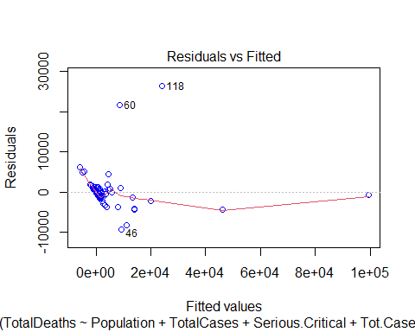 # Breusch-Pagan Test
bptest(step_model1)
##
## studentized Breusch-Pagan test
##
## data: step_model1
## BP = 26.412, df = 5, p-value = 7.423e-05

since p < 0.05 assumption homoscedasticity is vialated

2. Check Normality of Residuals

Normal Q-Q plot
plot(step_model1, which = 2, col ="blue")
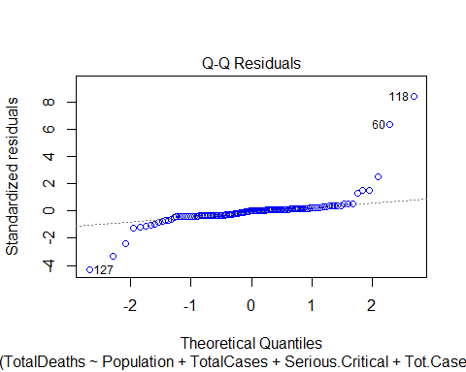 # Shapiro-Wilk Test
shapiro.test(step_model1$residuals)
##
## Shapiro-Wilk normality test
##
## data: step_model1$residuals
## W = 0.52154, p-value < 2.2e-16

Since p-value < 0.05 normality assumption is vialated.

3. Independence of Residuals

Residual vs Rund order
plot(residuals(step_model1),
xlab = "Observation Order",
ylab = "Residuals",
main = "Residuals vs Rund order/observation order/Time plot")
abline(h = 0, col = "red")
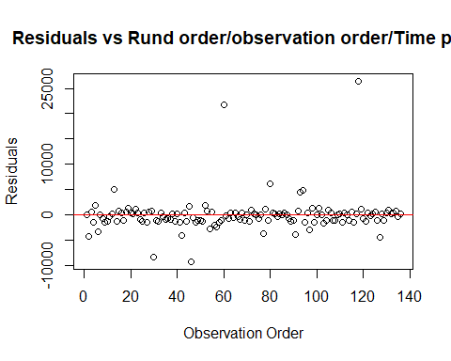 # Durbin-Watson Test
dwtest(step_model1)
##
## Durbin-Watson test
##
## data: step_model1
## DW = 2.0075, p-value = 0.5235
## alternative hypothesis: true autocorrelation is greater than 0

since p > 0.05 suggests no autocorrelation

Now we can see that two assumptions (Normality & Homoscedasticity (Constant Variance) of Residuals) are violated.

Let’s try using box-cox transformation
b <- boxcox(lm(TotalDeaths ~ ., data = train1[-c(5)]))
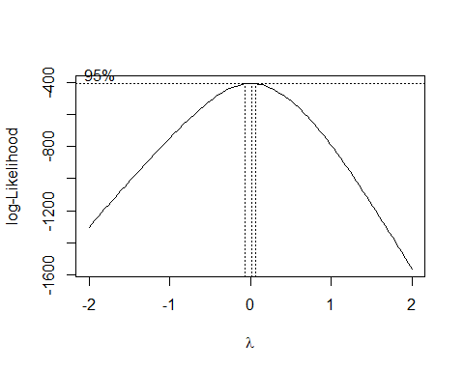
lambda <- b$x[which.max(b$y)]
lambda
## [1] 0.02020202

lambda = 0.02020202, this suggest log transformation is nearly optimal
model1_step <- lm(log(TotalDeaths) ~ ., data = train1[-c(5)])
step_model1 <- stepAIC(model1_step, direction = "both", trace = TRUE)
## Start: AIC=184.08
## log(TotalDeaths) ~ Continent + Population + TotalCases + ActiveCases +
## Serious.Critical + Tot.Cases.1M.pop + Deaths.1M.pop + TotalTests +
## Tests.1M.pop + WHO.Region
##
## Df Sum of Sq RSS AIC
## - Continent 5 14.727 407.04 179.09
## - ActiveCases 1 0.213 392.53 182.15
## - Population 1 0.770 393.08 182.35
## - Tot.Cases.1M.pop 1 0.820 393.13 182.36
## - TotalCases 1 1.912 394.23 182.74
## <none> 392.31 184.08
## - Serious.Critical 1 9.579 401.89 185.36
## - TotalTests 1 18.418 410.73 188.32
## - Tests.1M.pop 1 27.540 419.85 191.31
## - Deaths.1M.pop 1 33.773 426.09 193.31
## - WHO.Region 6 110.376 502.69 205.79
##
## Step: AIC=179.09
## log(TotalDeaths) ~ Population + TotalCases + ActiveCases + Serious.Critical +
## Tot.Cases.1M.pop + Deaths.1M.pop + TotalTests + Tests.1M.pop +
## WHO.Region
##
## Df Sum of Sq RSS AIC
## - ActiveCases 1 0.479 407.52 177.25
## - Population 1 1.508 408.55 177.59
## - Tot.Cases.1M.pop 1 1.605 408.65 177.63
## - TotalCases 1 3.146 410.19 178.14
## <none> 407.04 179.09
## - Serious.Critical 1 12.712 419.75 181.27
## - TotalTests 1 16.669 423.71 182.55
## + Continent 5 14.727 392.31 184.08
## - Tests.1M.pop 1 27.022 434.06 185.83
## - Deaths.1M.pop 1 36.108 443.15 188.65
## - WHO.Region 6 139.085 546.13 207.07
##
## Step: AIC=177.25
## log(TotalDeaths) ~ Population + TotalCases + Serious.Critical +
## Tot.Cases.1M.pop + Deaths.1M.pop + TotalTests + Tests.1M.pop +
## WHO.Region
##
## Df Sum of Sq RSS AIC
## - Population 1 1.080 408.60 175.61
## - Tot.Cases.1M.pop 1 2.020 409.54 175.92
## <none> 407.52 177.25
## - TotalCases 1 7.366 414.89 177.69
## + ActiveCases 1 0.479 407.04 179.09
## - Serious.Critical 1 12.279 419.80 179.29
## - TotalTests 1 19.430 426.95 181.59
## + Continent 5 14.993 392.53 182.15
## - Tests.1M.pop 1 27.700 435.22 184.19
## - Deaths.1M.pop 1 35.654 443.17 186.66
## - WHO.Region 6 141.386 548.91 205.76
##
## Step: AIC=175.61
## log(TotalDeaths) ~ TotalCases + Serious.Critical + Tot.Cases.1M.pop +
## Deaths.1M.pop + TotalTests + Tests.1M.pop + WHO.Region
##
## Df Sum of Sq RSS AIC
## - Tot.Cases.1M.pop 1 1.991 410.59 174.27
## <none> 408.60 175.61
## - TotalCases 1 6.292 414.89 175.69
## + Population 1 1.080 407.52 177.25
## - Serious.Critical 1 11.386 419.99 177.35
## + ActiveCases 1 0.051 408.55 177.59
## + Continent 5 15.499 393.10 180.35
## - Tests.1M.pop 1 30.244 438.84 183.32
## - Deaths.1M.pop 1 34.908 443.51 184.76
## - TotalTests 1 46.478 455.08 188.26
## - WHO.Region 6 140.713 549.31 203.86
##
## Step: AIC=174.27
## log(TotalDeaths) ~ TotalCases + Serious.Critical + Deaths.1M.pop +
## TotalTests + Tests.1M.pop + WHO.Region
##
## Df Sum of Sq RSS AIC
## <none> 410.59 174.27
## - TotalCases 1 8.436 419.03 175.04
## + Tot.Cases.1M.pop 1 1.991 408.60 175.61
## + Population 1 1.051 409.54 175.92
## + ActiveCases 1 0.222 410.37 176.20
## - Serious.Critical 1 13.452 424.04 176.66
## + Continent 5 16.472 394.12 178.70
## - Tests.1M.pop 1 28.253 438.84 181.32
## - TotalTests 1 45.083 455.67 186.44
## - Deaths.1M.pop 1 57.331 467.92 190.05
## - WHO.Region 6 143.623 554.21 203.07
summary(step_model1)
##
## Call:
## lm(formula = log(TotalDeaths) ~ TotalCases + Serious.Critical +
## Deaths.1M.pop + TotalTests + Tests.1M.pop + WHO.Region, data = train1[-c(5)])
##
## Residuals:
## Min 1Q Median 3Q Max
## -5.5123 -1.0450 0.1229 1.1657 5.2208
##
## Coefficients:
## Estimate Std. Error t value Pr(>|t|)
## (Intercept) 1.825e+00 5.567e-01 3.278 0.001357 **
## TotalCases 2.197e-06 1.377e-06 1.596 0.112997
## Serious.Critical -6.605e-04 3.277e-04 -2.016 0.046002 *
## Deaths.1M.pop 4.348e-03 1.045e-03 4.161 5.87e-05 ***
## TotalTests 4.758e-07 1.290e-07 3.690 0.000334 ***
## Tests.1M.pop -3.390e-06 1.161e-06 -2.921 0.004146 **
## WHO.RegionAfrica 2.133e+00 6.365e-01 3.351 0.001068 **
## WHO.RegionAmericas 3.226e+00 6.528e-01 4.943 2.44e-06 ***
## WHO.RegionEasternMediterranean 4.010e+00 7.136e-01 5.619 1.20e-07 ***
## WHO.RegionEurope 2.997e+00 6.231e-01 4.810 4.29e-06 ***
## WHO.RegionSouth-EastAsia 1.660e+00 9.118e-01 1.821 0.071023 .
## WHO.RegionWesternPacific 1.707e+00 7.974e-01 2.140 0.034283 *
## ---
## Signif. codes: 0 '***' 0.001 '**' 0.01 '*' 0.05 '.' 0.1 ' ' 1
##
## Residual standard error: 1.82 on 124 degrees of freedom
## Multiple R-squared: 0.5475, Adjusted R-squared: 0.5074
## F-statistic: 13.64 on 11 and 124 DF, p-value: < 2.2e-16

log transformation Step_model1 is at 5% significance level.

Residual Analysis

1. Check Homoscedasticity (Constant Variance)

Residual vs. Fitted Plot:
plot(step_model1, which = 1, col ="blue")
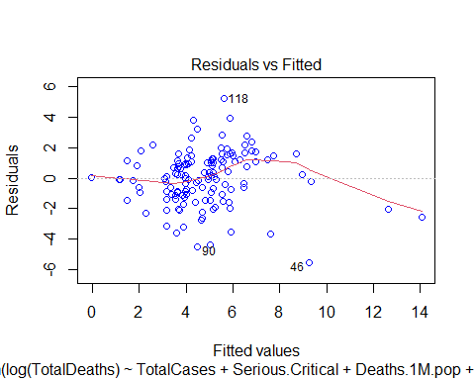

Breusch-Pagan Test
bptest(step_model1)
##
## studentized Breusch-Pagan test
##
## data: step_model1
## BP = 45.972, df = 11, p-value = 3.27e-06

since p < 0.05 assumption homoscedasticity is vialated

2. Check Normality of Residuals

Normal Q-Q plot
plot(step_model1,which = 2, col ="blue")
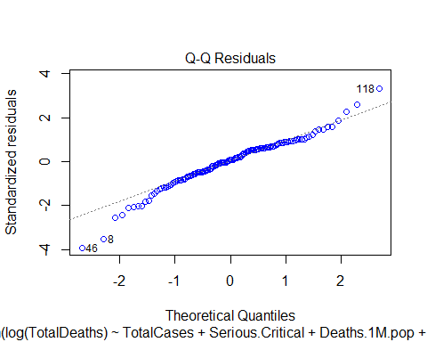 # Shapiro-Wilk Test
shapiro.test(step_model1$residuals)
##
## Shapiro-Wilk normality test
##
## data: step_model1$residuals
## W = 0.98484, p-value = 0.1377

Since p-value > 0.05 normality assumption is not violated.

3. Independence of Residuals

Residual vs Rund order
plot(residuals(step_model1),
xlab = "Observation Order",
ylab = "Residuals",
main = "Residuals vs Rund order/observation order/Time plot")
abline(h = 0, col = "red")
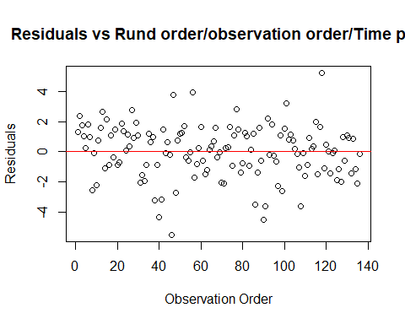 # Durbin-Watson Test
dwtest(step_model1)
##
## Durbin-Watson test
##
## data: step_model1
## DW = 1.895, p-value = 0.2714
## alternative hypothesis: true autocorrelation is greater than 0

since p > 0.05 suggests no autocorrelation between residuals.

The independence of residuals is not violated.

Still, we can see that two assumptions (Normality & Homoscedasticity (Constant Variance) of Residuals) are violated.

Let’s use Weighted Least Squares (WLS) to try to remove Homoscedasticity violations
model1_step <- lm(log(TotalDeaths) ~ ., data = train1[-c(5)])
weights <- 1 / residuals(model1_step)^2
wls <- lm(log(TotalDeaths) ~ ., data = train1[-c(5)],weights = weights)
step_model1 <- stepAIC(wls, direction = "both", trace = TRUE)
## Start: AIC=25.99
## log(TotalDeaths) ~ Continent + Population + TotalCases + ActiveCases +
## Serious.Critical + Tot.Cases.1M.pop + Deaths.1M.pop + TotalTests +
## Tests.1M.pop + WHO.Region
##
## Df Sum of Sq RSS AIC
## - ActiveCases 1 0.69 123.38 24.75
## - TotalCases 1 1.40 124.09 25.54
## <none> 122.69 25.99
## - Tot.Cases.1M.pop 1 2.73 125.42 26.98
## - Population 1 5.13 127.81 29.56
## - Serious.Critical 1 6.70 129.39 31.22
## - Continent 5 22.36 145.05 38.76
## - TotalTests 1 52.98 175.66 72.80
## - Deaths.1M.pop 1 71.61 194.30 86.51
## - Tests.1M.pop 1 104.04 226.73 107.51
## - WHO.Region 6 1248.32 1371.01 342.25
##
## Step: AIC=24.75
## log(TotalDeaths) ~ Continent + Population + TotalCases + Serious.Critical +
## Tot.Cases.1M.pop + Deaths.1M.pop + TotalTests + Tests.1M.pop +
## WHO.Region
##
## Df Sum of Sq RSS AIC
## - TotalCases 1 0.83 124.21 23.67
## <none> 123.38 24.75
## + ActiveCases 1 0.69 122.69 25.99
## - Tot.Cases.1M.pop 1 3.26 126.64 26.30
## - Population 1 4.50 127.87 27.62
## - Serious.Critical 1 6.72 130.10 29.97
## - Continent 5 35.95 159.33 49.53
## - Deaths.1M.pop 1 72.48 195.86 85.60
## - Tests.1M.pop 1 112.53 235.91 110.91
## - TotalTests 1 214.28 337.66 159.67
## - WHO.Region 6 1292.55 1415.93 344.63
##
## Step: AIC=23.67
## log(TotalDeaths) ~ Continent + Population + Serious.Critical +
## Tot.Cases.1M.pop + Deaths.1M.pop + TotalTests + Tests.1M.pop +
## WHO.Region
##
## Df Sum of Sq RSS AIC
## <none> 124.21 23.67
## + TotalCases 1 0.83 123.38 24.75
## + ActiveCases 1 0.12 124.09 25.54
## - Tot.Cases.1M.pop 1 4.48 128.69 26.49
## - Population 1 5.79 130.01 27.87
## - Serious.Critical 1 7.09 131.30 29.21
## - Continent 5 64.61 188.82 70.63
## - Deaths.1M.pop 1 76.39 200.60 86.86
## - Tests.1M.pop 1 119.42 243.63 113.29
## - TotalTests 1 389.82 514.03 214.83
## - WHO.Region 6 1318.74 1442.95 345.20

1. Check Homoscedasticity (Constant Variance)

Residual vs. Fitted Plot:
plot(step_model1, which = 1, col ="blue")
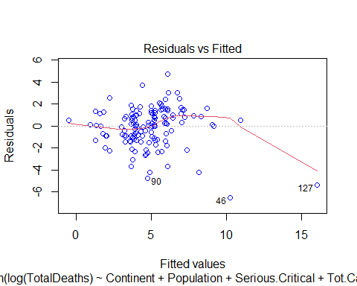
bptest(step_model1)
##
## studentized Breusch-Pagan test
##
## data: step_model1
## BP = 6513.2, df = 17, p-value < 2.2e-16

P-value < 0.05, still it is same, Homoscedasticity is violated

since p > 0.05 suggests no autocorrelation between residuals.

The independence of residuals is not violated.

Conclusion

Still, we can see that two assumptions (Normality & Homoscedasticity (Constant Variance) of Residuals) are violated.

Before we use mean imputation for Serious.Critical, next we use median imputation, but the result is still same Normality & Homoscedasticity (Constant Variance) of Residuals are violated.

After all, since we are using real life data, sometimes normality can be violated. So, we can neglect that, but the case we face is we can’t neglect Homoscedasticity (Constant Variance) of Residuals) assumption violation.
So, our conclusion is that the model is not suitable for predicting deathrate.

References
Kaggle: https://www.kaggle.com/datasets/imdevskp/corona-virus-report
R Packages: caTools, car, MASS, dplyr, lmtest
WHO & Worldometer data portals

Individual Contribution

Student Number | Name | Tasks
PS/2021/009 | DSY Dissanayaka | Problem Definition & Data Preparation | Led research question formulation and objective alignment.
PS/2021/025 | AJMVS Jayasingha | Problem Definition & Data Preparation | Data collection and initial cleaning (handling missing values).
PS/2021/050 | JANN Jayasinghe | Problem Definition & Data Preparation | Exploratory Data Analysis (EDA) and descriptive statistics.
PS/2021/068 | MDDI Senadheera | Modeling & Analysis | Implemented gls() with variance weighting (varPower).
PS/2021/069 | SASC Ariyarathna | Modeling & Analysis | Executed stepwise selection (stepAIC) and model comparison
PS/2021/111 | LMIK Thilakasir | Modeling & Analysis | Validated model assumptions (residual checks, QQ-plots).
PS/2021/112 | GJE Amarasinghe | Interpretation & Visualization | Interpreted coefficients and statistical significance.
PS/2021/121 | SD Hendawitharana | Interpretation & Visualization | Created visualizations (effect plots).
PS/2021/169 | GLL Hansamali | Documentation & Presentation | Prepared slides and technical report drafting.
PS/2021/176 | MDRD Rupasinghe | Documentation & Presentation | Rehearsed presentation flow and Q&A preparation.

